CUSTOMER PURCHASE DATA PREPROCESSING AND FEATURE ENGINEERING PROJECT REPORT
1. Introduction
Data preprocessing is one of the most important stages in Data Science and Machine Learning. In real-world applications, data collected from multiple sources is often incomplete, inconsistent, and contains missing values. Such raw data cannot be directly used for analysis or machine learning model development.
The main purpose of this project is to collect customer purchase-related data from multiple data sources, clean and preprocess the data, apply feature engineering techniques, visualize customer behavior patterns, and generate a final structured dataset ready for analysis.
This project demonstrates practical implementation of preprocessing techniques commonly used in real-world data analytics and machine learning pipelines.

2. Project Objective
The major objectives of this project are:
- To collect customer-related data from multiple different sources.
- To merge data from CSV, JSON, SQL, and API sources into a unified dataset.
- To identify and handle missing values and inconsistent records.
- To apply data preprocessing techniques for improving data quality.
- To perform feature engineering and generate useful additional features.
- To visualize customer purchase behavior using graphical analysis.
- To prepare a final cleaned dataset suitable for machine learning and business analytics.

3. Data Sources Used
The project uses four different types of data sources.
A. Customer Dataset (customers.csv)
This dataset contains customer demographic information.
Columns included:
- customer_id
- name
- age
- gender
- city
- income
The raw customer dataset intentionally contains missing values in age, city, and income columns for preprocessing practice.

B. Transaction Dataset (transactions.json)
This dataset contains customer transaction information.
Columns included:
- transaction_id
- customer_id
- product_id
- amount
- payment_mode
This file stores customer purchase history and payment details.

C. Product Dataset (products.sql)
Product data is stored inside SQL queries.
Columns included:
- product_id
- product_name
- category
- price
- stock
This SQL file was converted into database records using SQLite.

D. API Dataset
An external API source was used to simulate real-world external data integration.
Additional information collected:
- firstName
- lastName
- api_age
- api_gender
- email
- phone
- height
- weight
- bloodGroup
This demonstrates API integration skills during preprocessing.

4. Libraries Used
The following Python libraries were used during project development:
- Pandas
- NumPy
- Matplotlib
- SQLite3
- Requests
- Scikit-Learn
- SciPy
- Warnings
These libraries helped perform data loading, cleaning, preprocessing, visualization, database operations, and API extraction.

5. Data Collection and Loading Process
The first step of the project was importing all required libraries.
After importing libraries, data was loaded from multiple sources:
- customers.csv was loaded using Pandas.
- transactions.json was loaded as JSON structured data.
- products.sql was executed and converted into SQLite database records.
- API data was fetched using requests library.
Each dataset was analyzed using:
- head()
- shape
- columns
- info()
- describe()
This helped understand the structure and quality of raw data before preprocessing.

6. Data Merging Process
After loading all datasets, data merging was performed.
Step 1
Customer dataset was merged with transaction dataset using the common column customer_id.
Step 2
Merged dataset was joined with product dataset using product_id.
Step 3
API data was attached to the final merged dataset.
This created one complete dataset combining:
- customer information
- transaction details
- product information
- external API information
The purpose of merging was to combine multiple real-world data sources into one unified dataset for preprocessing.

7. Problems Found in Raw Data
After examining the raw dataset, several problems were identified.
Major issues found:
- Missing values in customer income column
- Missing values in city column
- Missing age values
- Missing transaction information
- Missing payment mode records
- Missing API merged data after joining
- Incomplete records
- Different data formats requiring integration
These issues made preprocessing necessary before analysis.

8. Missing Value Handling
Missing values were identified using:
- isnull()
- sum()
Two different methods were applied.
Numerical Missing Values
Numerical columns:
- age
- income
- amount
- price
- stock
Method used:
Mean Imputation
Reason:
Mean imputation helps preserve overall numerical distribution and avoids removing valuable records.

Categorical Missing Values
Categorical columns:
- city
- payment_mode
- gender
Method used:
Mode Imputation
Reason:
Mode replaces missing categories using the most frequently occurring value.
This improves data consistency.

9. Data Visualization and Analysis
Several visualization techniques were created to analyze customer behavior and data distribution.

A . Income Boxplot

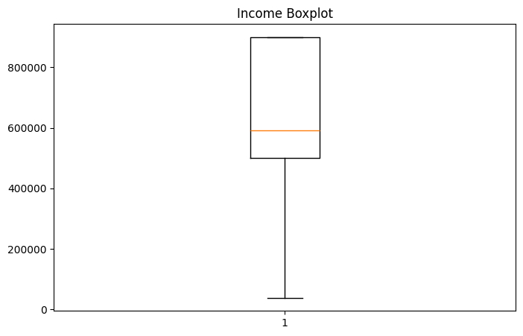
Observation:
The Income Boxplot was created to analyze the distribution of customer income values. It helps identify the spread of income levels among customers and detect possible outliers. The graph shows that most customers belong to medium and high income groups, while a few customers have significantly lower income values.
Purpose:
To study income spread and identify unusual income values.

B. Amount Boxplot

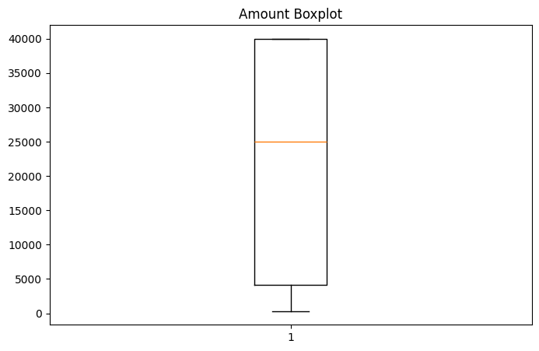
Observation:
The Amount Boxplot represents the distribution of customer transaction amounts. It helps identify unusual purchase values and outliers. The graph shows that some customers make high-value purchases while others make lower-value transactions.
Purpose:
To analyze customer purchasing amount variation.

C. Income vs Amount Scatter Plot
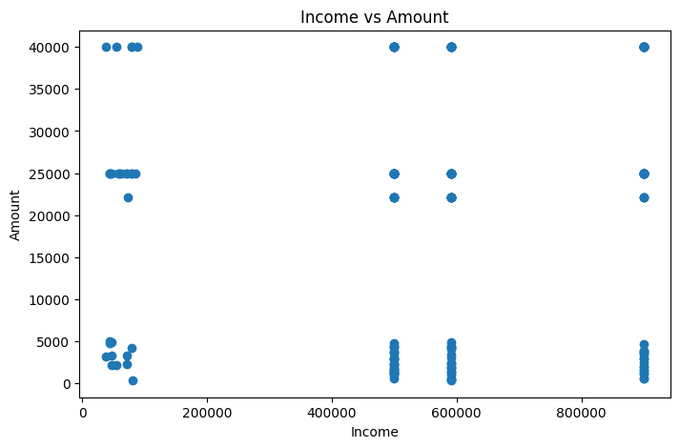Observation:
The scatter plot was created to study the relationship between customer income and purchase amount. This graph helps analyze whether higher income customers spend more money on transactions. The visualization shows different purchase patterns across customer income groups.
Purpose:
To analyze relationship between income and purchase behavior.

D. Payment Mode Distribution
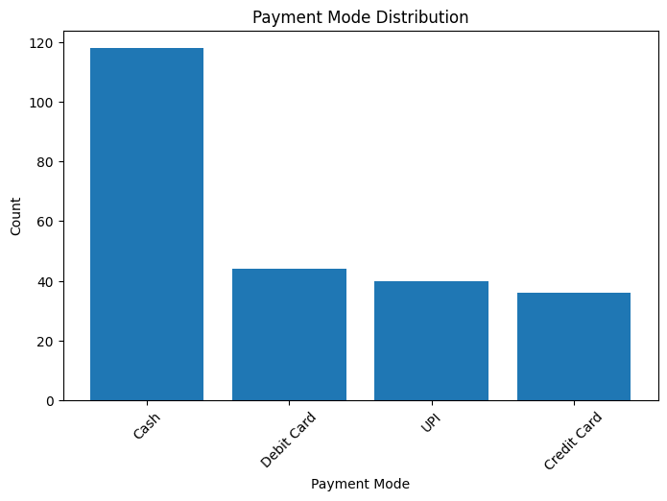Observation:
This bar chart shows the frequency distribution of different payment methods such as Cash, Credit Card, Debit Card, and UPI. The graph indicates customer payment preferences. Cash transactions were found to be more frequent compared to other payment methods.
Purpose:
To understand customer payment behavior.

E. Gender Distribution
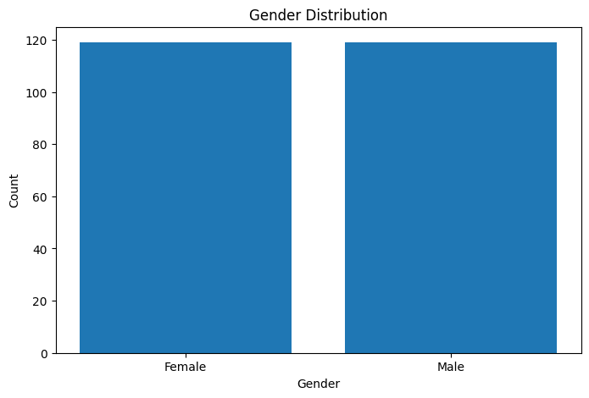Observation:
The Gender Distribution graph was created to analyze demographic balance in customer records. It shows the number of male and female customers present in the dataset. The graph indicates balanced customer representation.
Purpose:
To study customer demographic distribution.

F. Transaction Amount Distribution
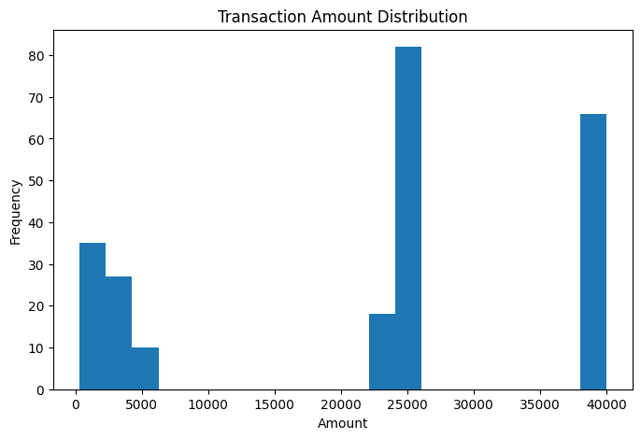Observation:
The Transaction Amount Distribution histogram shows how customer purchase amounts are distributed across the dataset. Most transactions are concentrated around certain purchase ranges, while some transactions are significantly higher than average.
Purpose:
To understand transaction behavior pattern.

G. Income Distribution
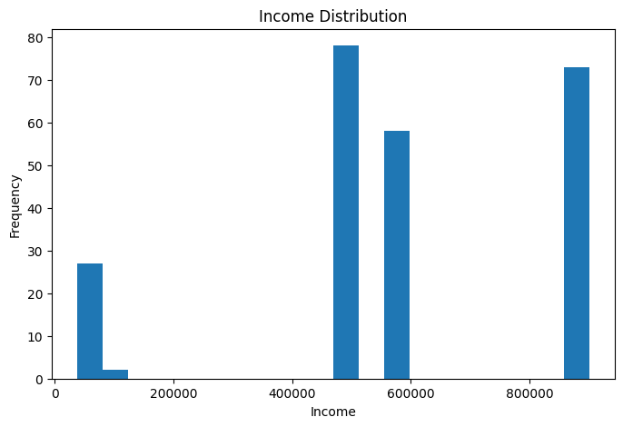Observation:
The Income Distribution histogram helps visualize the spread of customer income levels. Most customers belong to medium and high income groups while fewer customers belong to lower income categories.
Purpose:
To understand customer income segmentation.

10. Feature Engineering
Feature engineering was applied to create additional useful columns.
New features created:
- high_value_customer
- purchase_category
- product_number
Purpose:
To create additional business-related information useful for analysis and future machine learning models.
Feature engineering improves dataset quality and increases predictive capability.

11. Data Transformation Techniques
Several mathematical transformations were applied.
Techniques used:
- Log Transformation
- Square Root Transformation
- Reciprocal Transformation
- Box-Cox Transformation
- Yeo-Johnson Transformation
Purpose:
These transformations help normalize numerical distributions and reduce skewness.
Normalized data performs better in machine learning models.

12. Encoding Techniques
Categorical variables cannot be directly used by machine learning models.
Therefore categorical encoding was applied.
Label Encoding
Applied on:
- gender
- api_gender
Purpose:
Convert categorical labels into numerical values.

One Hot Encoding
Applied on:
- payment_mode
- category
Purpose:
Convert categorical variables into separate binary columns for machine learning compatibility.

13. Final Output Generated
After completing preprocessing and feature engineering, the final processed dataset was exported.
Final output file:
processed_customer_data.csv
The final dataset is now:
- Clean
- Structured
- Consistent
- Ready for analysis
- Suitable for machine learning
This dataset can now be used for predictive analytics and customer behavior analysis.

14. Best Methods Applied
The most effective preprocessing methods used in this project were:
- Mean Imputation for numerical missing values
- Mode Imputation for categorical missing values
- Label Encoding
- One Hot Encoding
- Feature Engineering
- Box-Cox Transformation
- Yeo-Johnson Transformation
These methods significantly improved final dataset quality.

15. Conclusion
This project successfully demonstrated complete end-to-end data preprocessing and feature engineering using multiple data sources including CSV, JSON, SQL, and API.
The raw dataset initially contained missing values, inconsistent records, incomplete transaction details, and multiple formatting issues.
These problems were solved using preprocessing techniques such as missing value handling, encoding, transformation, feature engineering, and visualization.
The final processed dataset named processed_customer_data.csv is now fully cleaned, structured, and ready for future machine learning, predictive modeling, and business analytics applications.
This project provided practical understanding of real-world data preprocessing workflow and demonstrated how raw business data can be transformed into valuable analytical information.

